practical: 1 | Implementation and Time analysis of sorting algorithms. Bubble sort, Selection sort, Insertion sort, Merge sort and Quicksort
19/08/2026

Aim: To Implement and Time analysis of sorting algorithms. Bubble sort, Selection sort, Insertion sort, Merge sort and Quicksort.
Algorithm:
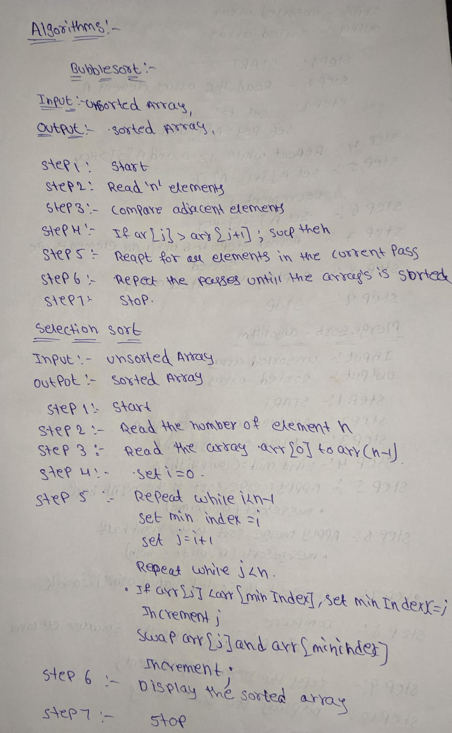

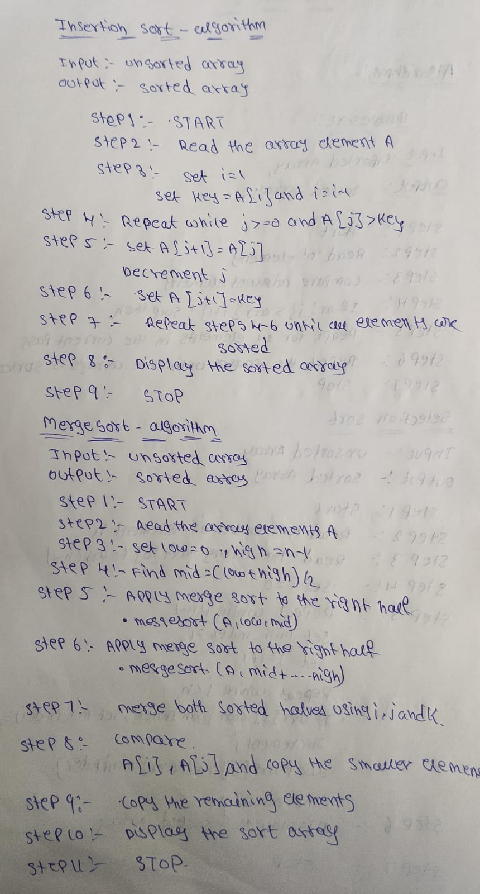
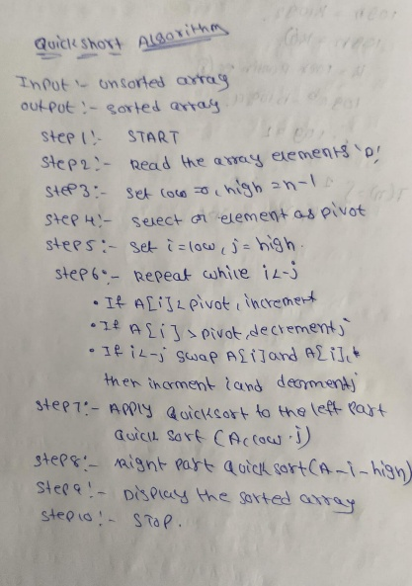

Program:

#include <iostream>
using namespace std;

// ---------------- BUBBLE SORT ----------------
void bubbleSort(int arr[], int n)
{
for (int i = 0; i < n - 1; i++)
{
for (int j = 0; j < n - i - 1; j++)
{
if (arr[j] > arr[j + 1])
swap(arr[j], arr[j + 1]);
}
}
}

// ---------------- SELECTION SORT ----------------
void selectionSort(int arr[], int n)
{
for (int i = 0; i < n - 1; i++)
{
int minIndex = i;

for (int j = i + 1; j < n; j++)
{
if (arr[j] < arr[minIndex])
minIndex = j;
}

swap(arr[i], arr[minIndex]);
}
}

// ---------------- INSERTION SORT ----------------
void insertionSort(int arr[], int n)
{
for (int i = 1; i < n; i++)
{
int key = arr[i];
int j = i - 1;

while (j >= 0 && arr[j] > key)
{
arr[j + 1] = arr[j];
j--;
}

arr[j + 1] = key;
}
}

// ---------------- MERGE SORT ----------------
void merge(int arr[], int low, int mid, int high)
{
int temp[100];
int i = low;
int j = mid + 1;
int k = low;

while (i <= mid && j <= high)
{
if (arr[i] < arr[j])
temp[k++] = arr[i++];
else
temp[k++] = arr[j++];
}

while (i <= mid)
temp[k++] = arr[i++];

while (j <= high)
temp[k++] = arr[j++];

for (i = low; i <= high; i++)
arr[i] = temp[i];
}

void mergeSort(int arr[], int low, int high)
{
if (low < high)
{
int mid = (low + high) / 2;

mergeSort(arr, low, mid);
mergeSort(arr, mid + 1, high);

merge(arr, low, mid, high);
}
}

// ---------------- QUICK SORT ----------------
int partition(int arr[], int low, int high)
{
int pivot = arr[high];
int i = low - 1;

for (int j = low; j < high; j++)
{
if (arr[j] < pivot)
{
i++;
swap(arr[i], arr[j]);
}
}

swap(arr[i + 1], arr[high]);

return i + 1;
}

void quickSort(int arr[], int low, int high)
{
if (low < high)
{
int p = partition(arr, low, high);

quickSort(arr, low, p - 1);
quickSort(arr, p + 1, high);
}
}

// ---------------- DISPLAY ----------------
void display(int arr[], int n)
{
for (int i = 0; i < n; i++)
cout << arr[i] << " ";

cout << endl;
}

// ---------------- MAIN ----------------
int main()
{
int n;
int original[100];

cout << "Enter number of elements: ";
cin >> n;

cout << "Enter elements: ";
for (int i = 0; i < n; i++)
cin >> original[i];

int bubble[100], selection[100], insertion[100];
int mergeArr[100], quick[100];

// Copy original array
for (int i = 0; i < n; i++)
{
bubble[i] = original[i];
selection[i] = original[i];
insertion[i] = original[i];
mergeArr[i] = original[i];
quick[i] = original[i];
}

// Sorting
bubbleSort(bubble, n);
selectionSort(selection, n);
insertionSort(insertion, n);
mergeSort(mergeArr, 0, n - 1);
quickSort(quick, 0, n - 1);

// Display results
cout << "\nBubble Sort: ";
display(bubble, n);

cout << "Selection Sort: ";
display(selection, n);

cout << "Insertion Sort: ";
display(insertion, n);

cout << "Merge Sort: ";
display(mergeArr, n);

cout << "Quick Sort: ";
display(quick, n);

return 0;
}

Output:
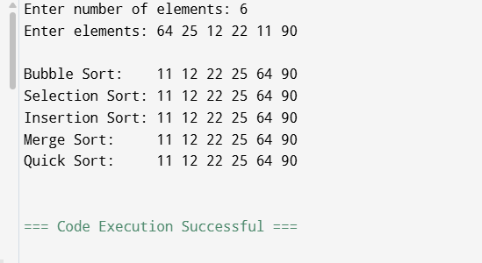

Time Complexity:
BUBBLE SORT:
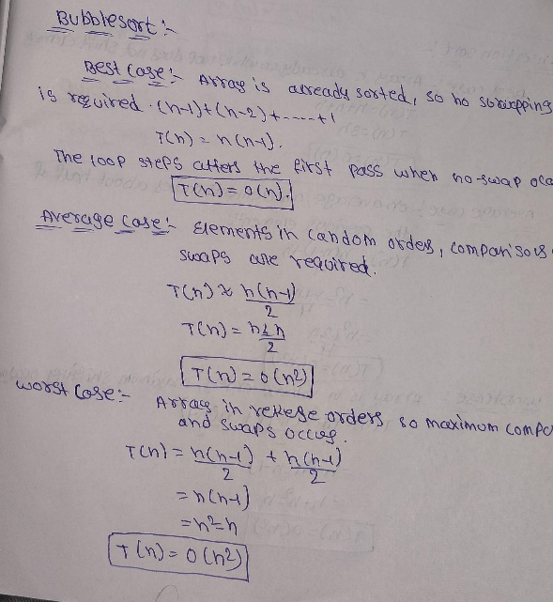
INSERTION SORT:
Best Case:
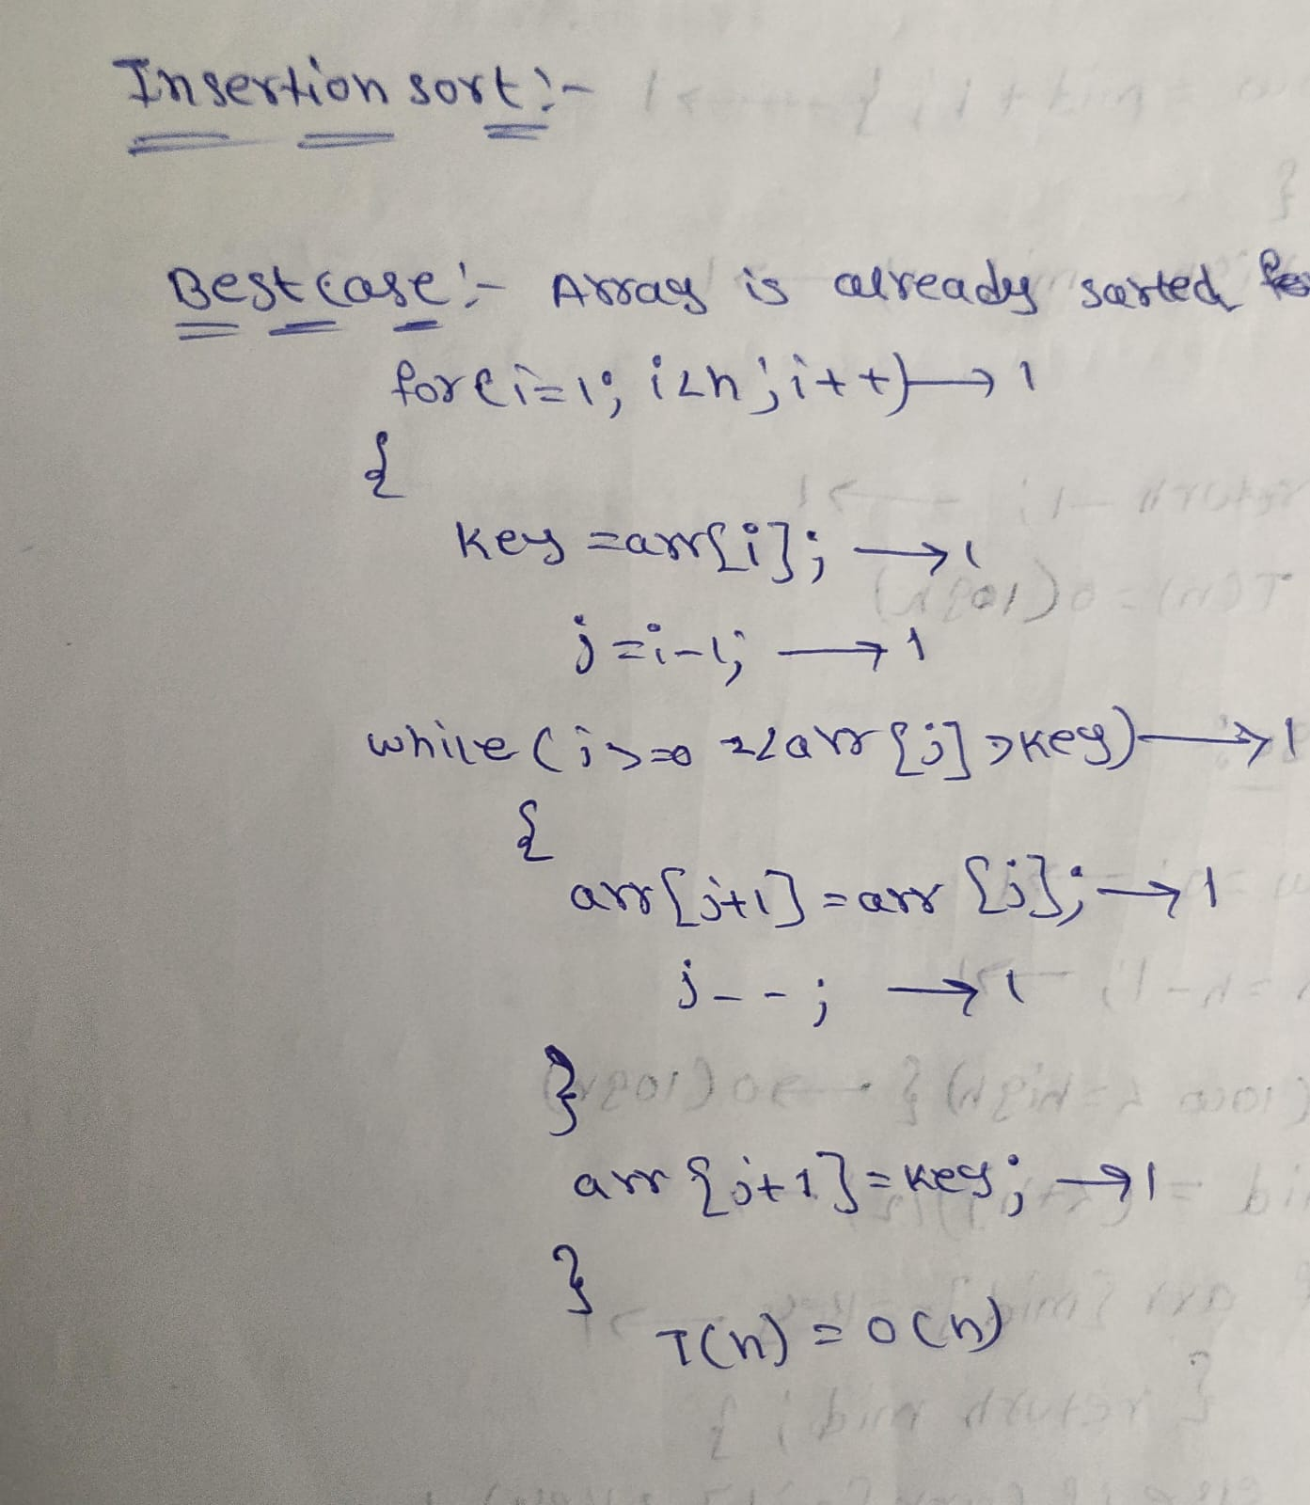
Average Case:
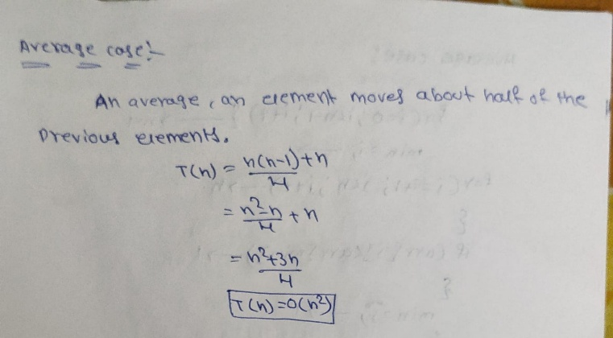
Worst Case:
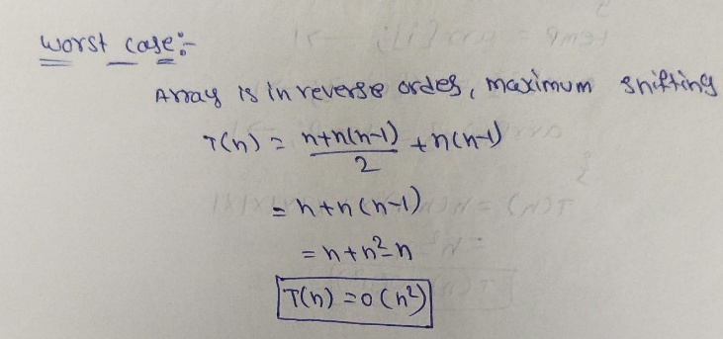
SELECTION SORT:
Best Case:
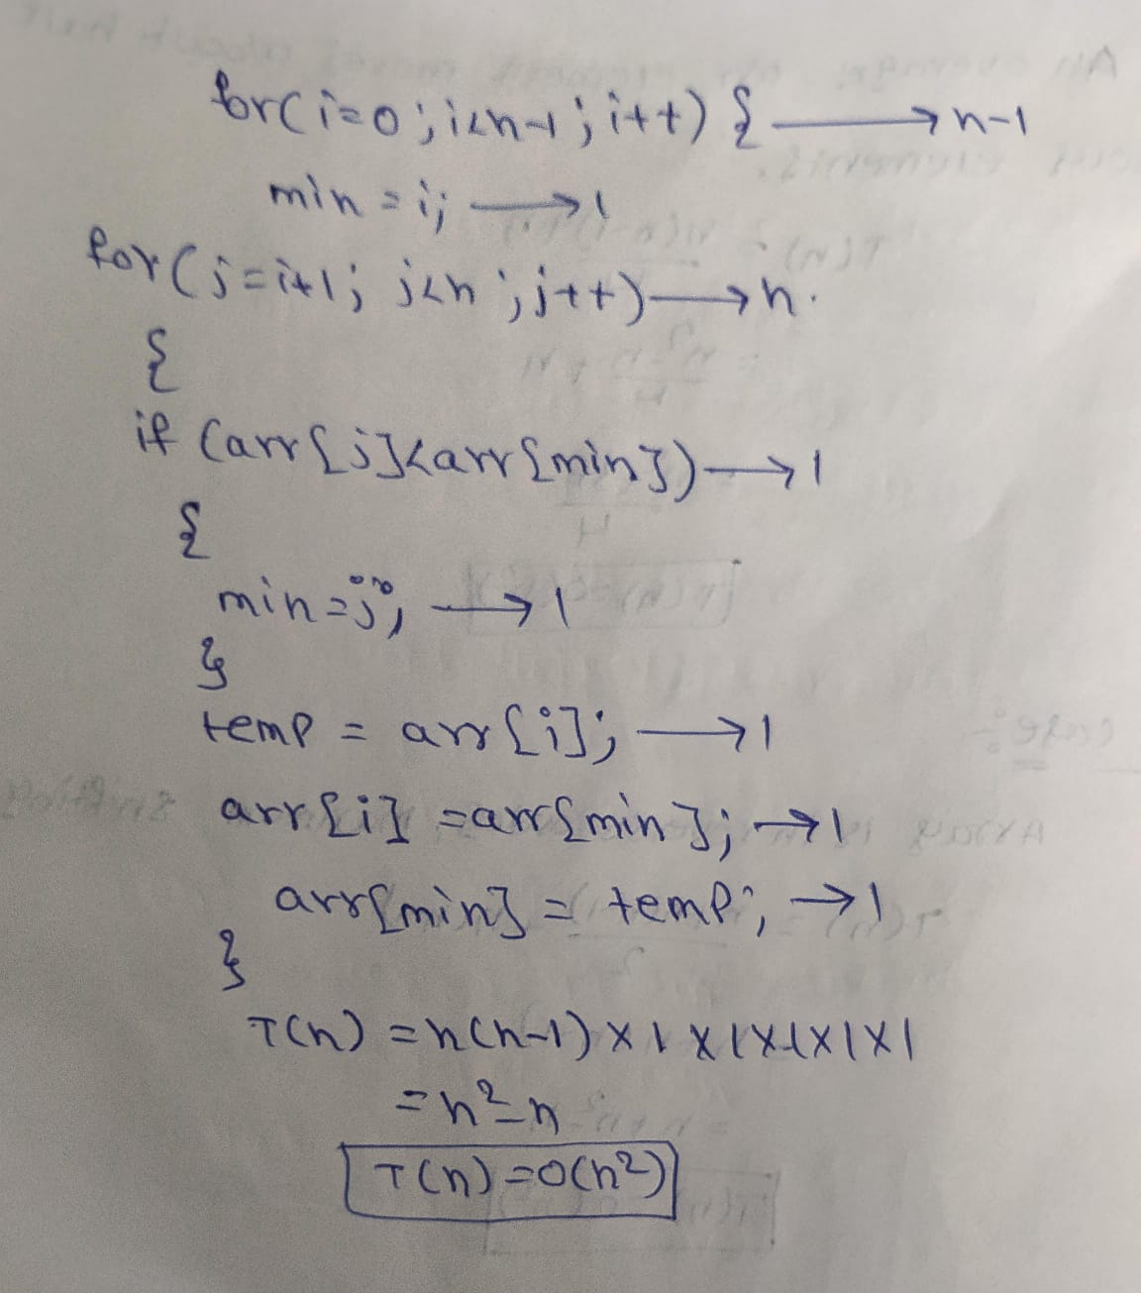

Average Case:


Worst Case:


MERGE SORT:
Best Case, Average Case, Worst Case:
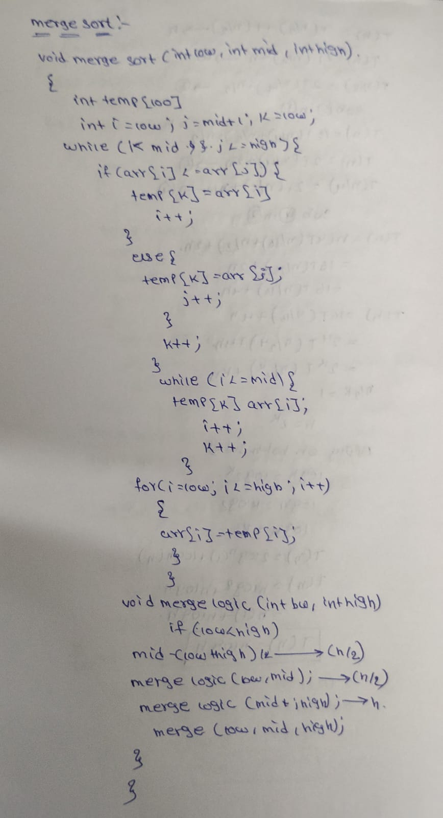
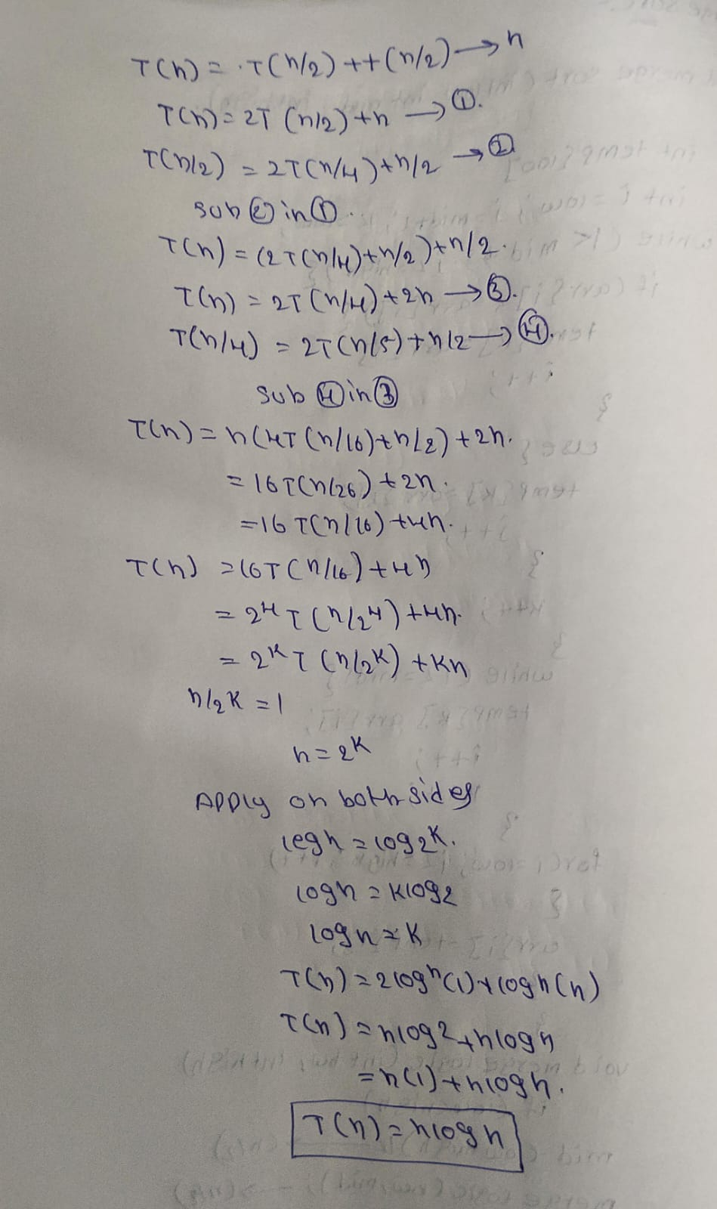

QUICK SORT:
Best case:
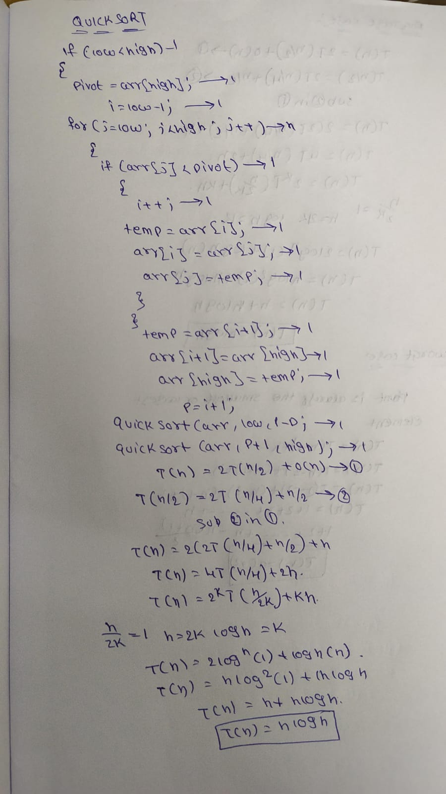

Average Case:
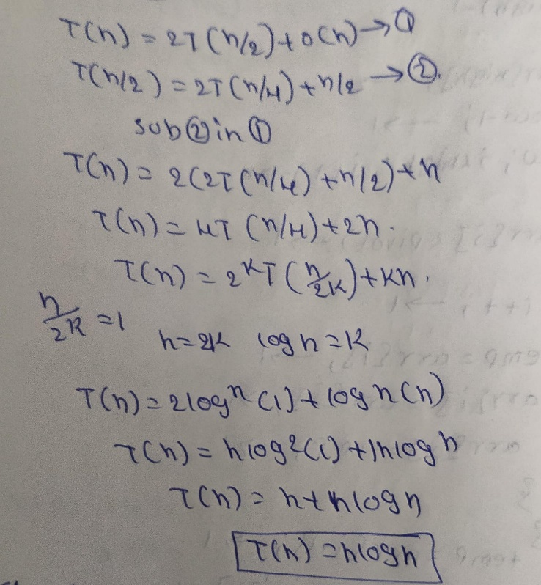
Worst Case:
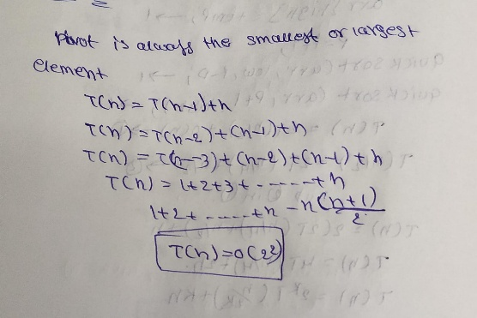

Conclusion:
I understood that different sorting algorithms use different ways to arrange data. Bubble, Selection and Insertion Sort are easy to understand and implement, but they can take more time for large data. Merge Sort and Quick Sort use a divide-and-conquer approach and are generally more efficient for large datasets. Overall, choosing an algorithm depends on the size and condition of the data and the require.

